Task 1 Task 2
Relational tables course, student and Data inserted in each table
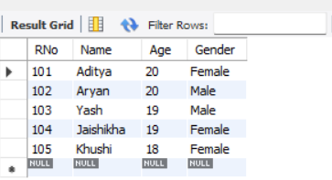
enroll created
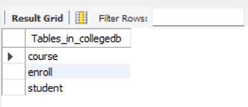

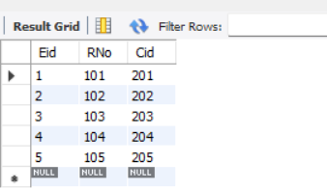
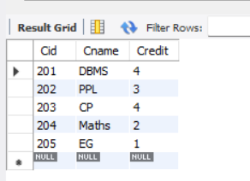

Task 3 Task 4
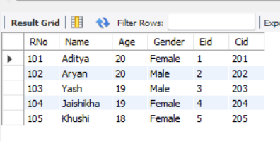
Student and Enroll tables joined Result of task 3 joined with course

Task 5
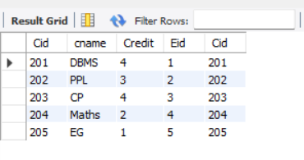
Enroll and Course table joined

Task 6
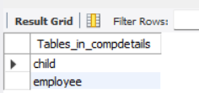
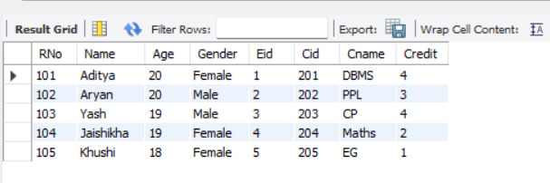
student table joined with enroll and course join

Task 1
Child and employee table created

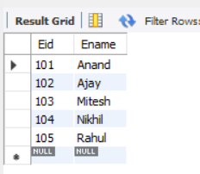
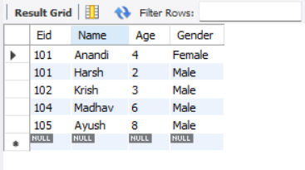
Task 2 -Data inserted in both tables

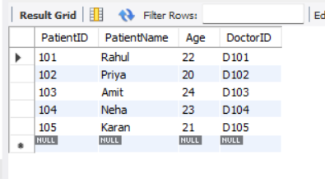
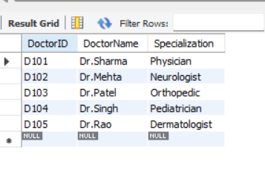
Task 1 – Relational tables created and data inserted in it.
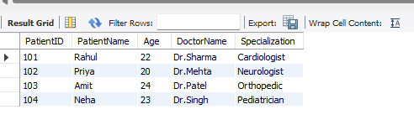
Task 2 JOIN operation performed between the Doctor and Patient Tables

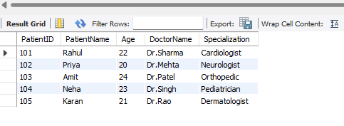
Task 3 Update operation with specialization of doctor with ID D101

Task 4 Delete Operation on patient with PatientID 105
